CHAPTER-I
INTRODUCTION

INTRODUCTION
The Human Resources Management (HRM) function includes a variety of activities, and key among them is deciding what staffing needs you have and whether to use independent contractors or hire employees to fill these needs, recruiting and training the best employees, ensuring they are high performers, dealing with performance issues, and ensuring your personnel and management practices conform to various regulations. Activities also include managing your approach to employee benefits and compensation, employee records and personnel policies. Usually small businesses (for-profit or nonprofit) have to carry out these activities themselves because they can't yet afford part- or full-time help. However, they should always ensure that employees have -- and are aware of -- personnel policies which conform to current regulations. These policies are often in the form of employee manuals, which all employees have.
Note that some people distinguish a difference between HRM (a major management activity) and HRD (Human Resource Development, a profession). Those people might include HRM in HRD, explaining that HRD includes the broader range of activities to develop personnel inside of organizations, including, eg, career development, training, organization development, etc.
There is a long-standing argument about where HR-related functions should be organized into large organizations, eg, "should HR be in the Organization Development department or the other way around?"
The HRM function and HRD profession have undergone tremendous change over the past 20-30 years. Many years ago, large organizations looked to the "Personnel Department," mostly to manage the paperwork around hiring and paying people. More recently, organizations consider the "HR Department" as playing a major role in staffing, training and helping to manage people so that people and the organization are performing at maximum capability in a highly fulfilling manner.

PAYROLL MANAGEMENT
DEFINITIONS:
In a company, payroll is the sum of all financial records of salaries, wages, bonuses and deductions.
Payroll Management is the linchpin to most of the information an organization has regarding its employees. While many organizations espouse to using Human Resource Information Systems (HRIS), the reality is somewhat different. Current technology and software packages allow employers to store a vast array of inter-related information about employees. However, much of this information is not viewed as critical, and therefore often overlooked. Basic employee information must however be kept for payroll purposes. This will also form the basis for any other HR related information.

Information recorded will include:
- Name
- Address,
- Date of birth
- Country of birth
- Marital status
- Salary level
- Taxation status
- Positions held
- Leave history
- Service history
Much of this is gathered when an employee is first registered on the payroll, but why is this important? Human resources can utilize this information to produce workforce profiles such as age, salary distribution, geographic location, and service length. All of these allow for greater HR planning. It is therefore imperative that payroll and HR have a clear line of communication.
This however is just the tip of the iceberg. Other reasons for ensuring clear communication between HR and payroll are:

- HR relies on payroll for historic information for reporting purposes, annual reports etc.
- Any plans to change award or enterprise agreement conditions must include input from the payroll area.
- Some payroll systems may not be capable of managing initiatives such as salary sacrificing, share schemes, or international employment.
- Any changes to conditions can result in higher payroll costs due to inefficient ‘work-around’ or an increased need for payroll resources.

NEED FOR BASIC PURPOSES OF EMPLOYEE PAYROLL
Employee Payroll of the employees is important if the employees are satisfied then only the organization can function smoothly increases its production, faces competition. If employees are satisfied with their job they will carry a positive attitude. Hence the study has been undertaken to assess the employee job Payroll which is necessary for the organization in order to make sound decisions.
- To increase productivity.
- To improve quality.
- To help a company fulfill its future personnel needs.
- To improve organizational climate.
- To improve health & safety.
- Obsolescence prevention.
- Personal growth.

SCOPE OF THE STUDY
The scope of the study consists of analyzing the compensation and benefits given for the employees at Biological E Ltd., An analysis of the process was carried out and recommendations were given accordingly. A questionnaire survey was conducted among Mangers, Executives, Supervisors and Workmen covering the following departments.
- HR department.
- General administration department.
- Packing department.
- Sales department.
- Finance department.

OBJECTIVES OF THE STUDY
- To study the process of Human resource planning at BIG BAZAAR.
- To study the payroll management at BIG BAZAAR.
- Does it follows the conventional method or developed any method of its own.
- To study the process of socialization of the new employee at BIG BAZAAR.
- To know The Criterion of Grading a Candidates Personal Capabilities.

RESEARCH METHODOLOGY
THE PRESENT STUDY
The research, method of study explains the systematic way of finding the predetermined objectives. Moreover this provides the clean path to accomplish and achieve clear solution for the problem stated. The following are stages through which the research has passed to obtain the conclusions:
- RESEARCH DESIGN:
- In this study, the research design used is descriptive in nature as it describes the views, opinions and perception of the employees.
- COLLECTION OF DATA:
- This study uses both pr imary and secondary data. Primary data refers to the first hand information that is collected through questionnaire and on personal interviews. Secondary data refers to the data that is not originally collected but rather obtained from published or unpublished sources, i.e., information about the performance of the company, reports on the study, review of literature etc.
METHODS OF DATA COLLECTION:
Questionnaire is prepared and circulated to the employees to know their opinion on the “Manpower planning” in the organization. Questionnaire consists of close ended questions which pre-specify all the answers and respondents make a choice among them. While collecting the data, since women were not able to read the questionnaire personal interview was conducted by translating the questionnaire into a language which is understandable by them to know about the functions of human resources activities implemented in the organization.
SAMPLE SIZE:
The sample size selection for research is 60. This sample size was selected by using random sampling technique.
DATA ANALYSIS:
After the data have been collected it has to be analyzed, the data obtained from the questionnaire is arranged in a serial order. Then a copy with tabulation method is being prepared.
Tabulation is a part of the technical procedure where in classified data are put in the form of tables. The tables thus obtained were analyzed with statistical techniques like percentage, pie diagrams.

LIMITATIONS OF THE STUDY
- The primary data inference through personal interaction with the employees may have an element of bias from the point of view of employee individual perspective.
- The understanding and knowledge may vary from person to person. The replies given by respondents are assumed to be true, though they are not uniform.
- The survey is limited to the employees of BIG BAZAAR, bids, Hyderabad.
- Employee Insurance & Provident fund processing
- Quality Audit procedures & planning

CHAPTER-II
INDUSTRY PROFILE
&
COMPANY PROFILE

INDUSTRY PROFILE
PROFILE OF THE ORGANISATION:
Big bazaar – is se sasta aur accha kahin nahi
Type – subsidiary of pantaloon group
Founded – 2001
Head quarters – Jogeshwari, Mumbai, India
Industry – retail
Products – department stores
Parents – future group
Website – http://www.bigbazaar.com
BOARD OF DIRECTORS:
Mr. Kishore Biyani, Managing Director
Mr. Gopikishan Biyani, Whole time Director
Mr. Rakish Biyani, Whole time Director
Mr. Vijay Biyani, Whole time Director
Mr. Vijay Kumar Chopra, Independent Director
Mr. Shailesh Haribhakti, Independent Director
Mr. S Doreswamy, Independent Director
Dr. D O Koshy, Independent Director
Ms. Bala Deshpande, Independent Director
Mr. Anil Harish, Independent Director
MAJOR MILE STONES:
1987
Company incorporated as Manz Wear Private Limited. Launch of Pantaloons trouser, India’s first formal trouser brand.
1991
Launch of BARE, the Indian jeans brand.
1992
Initial public offer (IPO) was made in the month of May.

1994
The Pantaloon Shoppe – exclusive menswear store in franchisee format launched across the nation. The company starts the distribution of branded garments through multi-brand retail outlets across the nation.
1995
John Miller – Formal shirt brand launched.
1997
Company enters modern retail with the launch of the first 8000 square feet store, Pantaloons in Kolkata.
2004
Three Big Bazaar stores launched within a span of 22 days in Kolkata, Bangalore and Hyderabad.
2006
Food Bazaar, the supermarket chain is launched.
2008
Central - India’s first seamless mall is launched in Bangalore.
2010
Group moves beyond retail, acquires stakes in Galaxy Entertainment, Indus League Clothing and Planet Retail. Sets up India’s first real estate investment fund Kshitij to build a chain of shopping malls.
2012
Future Capital Holdings, the company’s financial is formed to manage over $1.5 billion in real estate, private equity and retail infrastructure funds. Plans forays into retailing of consumer finance products. Home Town, a home building and improvement products retail chain is launched along with consumer durables format, Ezone and furniture chain, Furniture Bazaar. Future Group enters into joint venture agreements to launch insurance products with Italian insurance major, generally. Forms joint ventures with US office stationery retailer, Staples.
2013
Future Group crosses $1 billion turnover mark. Specialized companies in retail media, logistics, IPR and brand development and retail-led technology services become operational.
Pantaloon Retail wins the International Retailer of the Year at US-based National Retail Federation convention in New York and Emerging Retailer of the Year award at the World Retail Congress held in Barcelona. Futurebazaar.com becomes India’s most popular shopping portal.
2015
Future Capital Holdings becomes the second group company to make a successful Initial Public Offering in the Indian capital markets. Big Bazaar crosses the 100-store mark, marking one of the fastest ever expansion of a hypermarket format anywhere in the world. Total operational retail space crosses 10 million square feet mark. Future Group acquires rural retail chain, Aadhar present in 65 rural locations.
AWARDS & RECOGNITIONS:
2014
CNBC Awaaz Consumer Awards 2014
Images Fashion Forum 2014
Coca-Cola Golden Spoon Awards 2014
2012
Indian Retail Forum Awards 2012
The Indiastar Award 2012
Retail Asia Pacific 500 Top Awards 2012
Coca-Cola Golden Spoon Awards 2012
The Reid & Taylor Awards for Retail Excellence 2012
The Reid & Taylor Awards for Retail Excellence 2012
2011
Images Retail Awards
National Retail Federation Awards
World Retail Congress Awards
Hewitt Best Employers 2007
PC World Indian Website Awards
Reader’s Digest Trusted Brands Platinum Awards
2010
Retail Asia Pacific Top 500 Awards
Asiamoney Awards
Ernst & Young Entrepreneur of the Year Award
CNBC Indian Business Leaders Awards
Images Retail Awards
Readers’ Digest Awards
CNBC Awaaz Consumer Awards
Reid & Taylor Awards for Retail Excellence
2009
DAKS London
2008
Images Retail Awards 2004
Reid & Taylor and DLF Awards
2007
Indian Express Award
COMPANY PROFILE

INTRODUCTION TO BIG BAZAAR
- A chain of shopping malls in India currently with 31 outlets owned by Kishore Biyani pantaloon group.
- Big bazaar is not just hyper market.
- Provides the best products at the best price.
- Reflects the look and feel of Indian bazaars at their moderns outlets.
- Allover India, big bazaar attracts a few thousands customers on any regular day.
MISSION AND VISION
- Future group shall deliver every thing, every where, every time for every Indian customer in the most profitable manner.
- We share the vision and belief that our customers and stakeholders shall be served only by creating and executing future scenarios in the consumption space leading to economic development.
TARGET AUDIENCE
- Big bazaar targets higher and upper middle class customers.
- The large and growing young working population is a preferred customer segment.
- Big bazaar specifically targets working women and home makers who are the primary decision maker.
STUDY OF DISTRIBUTION AND LOGISTICS ON BIG BAZAAR
RETAILING IN INDIA:
- The Indian retail industry accounts for 10% of GDP and 85% of employment.
- India is being treated as the next big retail destination with an average three year compounded annual growth rate of 46.64%.
- The Indian economy is poised to take the third position in the world in terms of purchasing power parity by the year 2014
- The Indian retail market is a Rs.1,200,000 million market as per the images India retail report 2014
- Organized retail market is zooming ahead with an annual growth rate of 30%.
- The country will have over300 malls translating to over 100 million sq. ft in available malls pace by the end of 2014
DIFFERENT ELEMENTS OF RETAIL MIX:
- Merchandise Assortment
- Location
- Price
- Visual merchandising
RETAIL MIX CONTD:
- Store Atmosphere
- Customer Service
- Advertising
- Promotion
- Personal Selling
INTERNAL ATTRIBUTES:
    - Envelop
    - Internal Layout
    - Methods of Display
    - Visual Merchandising
DISTRIBUTION:
    - It is one of the 4 Aspects of Marketing.
    - Traditionally distribution has been seen as dealing with to get the Product or Service to the Customers.
    - It is done by distributor who is in the middleman between the Manufacturer and Retailer.
LOGISTICS:
    - It is the Art and Science of Managing and Controlling the flow of Goods, Energy, Information and other Resources like Products, Services and people from the source of Production to the Market Place.
    - Its important to have Professional logistical support.
    - The operating responsibility of logistics is the Geographical repositioning of raw materials, work in process and finished inventories where required at the lowest cost possible.
PROMOTION:

- Low prices on Wednesday
- Concepts of Big days
- Promotional Offers
SWOT ANALYSIS
STRENGTHS
- Better understanding of customers helping the company to serve them better.
- Vast range of products under one roof helping in attracting customer and their family to shop together and enjoy the experience.
- Benefits of early into the retail industry.
- Diversified business operating allover India in various retail formats.
- Ability to get products from customer at discounted price due to the scale of business.
WEAKNESS

- High cost of operation due to large fixed costs.
- Very thin margin.
- High attraction rate of employees.
OPPORTUNITIES

- Lot of potential in the rural market.
- Can enter into production of various products due to its in depth understanding of customer’s tastes and preferences.
- Can expand the business in smaller cities as there is a lot of opportunity.
THREATS

- High business risk involved.
- Lot of competitions comings up to top the market potential.
- Margin of business reducing all the firms.

SUPPLY CHAIN:
A Supply Chain is a coordinated system of organizations, people, activities, information and resources involved in moving a product or service in physical or virtual manner from supplier to customer.
Supply chain activities transform raw materials and components into a finished product that is delivered to the end of customer.
SUPPLY CHAIN MANAGEMENT

Factory

C&L Agent

Distributor

Large retailer
Modern trade retailer
Whole seller

Small retailer

ORGANISATIONAL HIERARCHY

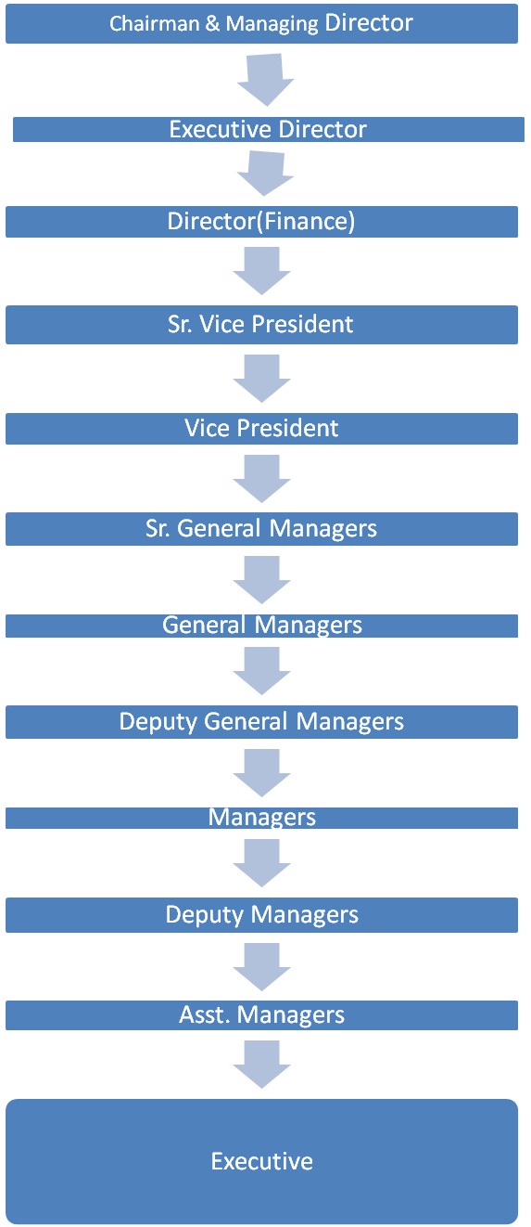

HR DEPARTMENT CHART

VICE PRESIDENT (HR AND LEGAL)

MANAGER (LEGAL)

SR.GENERAL MANAGER (HR)
CONFIDENTIAL EXECUTIVE

DEPUTY MANAGER (HR)

ASSt. MANAGER
SECURITY EXECUTIVE
HOSPITALITY AND HOUSE KEEPING EXE

JOB DESCRIPTION OF HR DEPARTMENT EMPLOYEES:

VICE PRESIDENT(HR AND LEGAL):
- Vice President is head of the department.
- Solves legal issues of the company.

MANAGER(LEGAL):
- Assists the vice president with the legal issues.

SR. GENERAL MANAGER:
- Takes care of responsibility of executive under him.
- Supervises work of executive under him.

CONFIDENTIAL EXECUTIVE:
- Collecting joining reports.
- Preparing performance appraisals.
- Increments
- Transfers
- Promotions
- Personal files of executives.

DEPUTY MANAGER:
- Handling union issues and few other hr works

ASS. MANAGER:
- Supervises time office executives.

SECURITY EXECUTIVE:
- Security department.
- Prepares duty charts of drivers.
- Takes care of transport.

MANAGEMENT TRAINEE:
- Assists the supervisors.
- Takes care of pay rolls of staff and workmen

HOSPITALITY AND HOUSE KEEPING:
- Takes care of guest relation.
- Preparing daily menu’s,budgets.
- Booking of banquet,conference hall.
- Arrangement of meeting.
- Planning and designing events for VIP.
- Preparation of duty charts.

TIME OFFICE
Time office at be is one of the main divisions of human resourcesdepartment, which links to all the four units of operation at BE.
As the name suggests Time Office is in charge of all the workers, staff, executives and officers presence in the company
The hierarchy is as shown below:

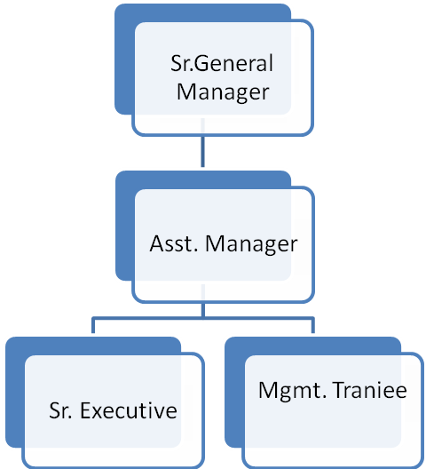

THE FUNCTIONS OF TIME OFFICE:
    - Attendance which includes in time and out time details.
    - Pay role system
    - Engagement of casual and contract laborers.
    - Monitoring absenteeism and late coming.
    - Preparation of over time statements, daily manpower reports and rooster allocation
    - Payment of advances to the employee and incentives
    - Payment of allowances and incentives
    - Maintenance of leave records and its control
    - Accident reports, implementation of PF and ESI to all employees
    - Issue of identity cards.
    - Issue of token for lunch and tea.

 |  |  | PAY SLIP FOR STAFF/WORKMEN
empoyee no: |  | PF no: |  | SB A/C no: |  | sl no:
Name: |  | no. of days: |  | ESI A/C no: |  | lop mts:
____________________________________________________________________________
EARNINGS |  |  | DEDUCTION
Basic |  |  | EPF: |  | LOP Amt:
ADNL Basic: |  |  | - |  | Prof Tax:
DA: |  |  | VPF: |  | Canteen:
SWA: |  |  | ESI: |  | Qrtr Rent:
Arrear 1: |  |  | LIC: |  | Jensheng:
HRA: |  |  | Home Loan: |  | Sal Adv:
Arrear 2: |  |  | BOB Loan: |  | Gen Adv:
CONV allowance: |  |  | Trust Recvry: |  | Veh Adv:
EDNL allowance: |  |  | B.B.K Loan: |  | EDNL Adv:
Night allowance: |  |  | Artel Loan: |  | Fest Adv:
Special allowance: |  |  | HDFC: |  | Other Ded:
Other earnings: |  |  | Union Sub: |  | LW Fund:
CF Paise: |  |  | SBH Loan: |  | LW Paise:
GROSS PAY: |  |  | TOTAL DED: |  | NET SAL:
PF Deduction on:
_____________________________________________________________________________
 |  |  | CUMULATIVE
EPF: |  | LIC:
FPF: |  | ESI: |  | GROSS PAY:
VPF: |  | PROF. TAX |  | TOTAL PAY:

 |  |  | PAYSLIP FOR EXECUTIVE
empoyee no: |  | PF no: |  | SB A/C no: |  |  | Sl No:
Name: |  | no. of days: |  | ESI A/C no: |  |  | lop:
__________________________________________________________________________
EARNINGS |  |  |  | DEDUCTION
Basic |  |  | EPF: |  | LOP Amt:
DA: |  |  | - |  | Prof Tax:
Arrear 1: |  |  | VPF: |  | INC Tax:
HRA: |  |  | ESI: |  | Canteen:
Paper allowance: |  |  | LIC: |  | Qtr Rent:
Special allowance: |  |  | Home Loan: |  | Biona
Ser/SWG allowance: |  |  | BOB Loan: |  | Sal Adv
CONV allowance: |  |  | Canfin Homes |  | Gen Adv:
Arrear 2: |  |  | LIC Housing: |  | Veh Adv:
Reimbursment |  |  | Artel Loan: |  | Other Ded:
Other earnings: |  |  | HDFC: |  | LW Paise(-):
LOC allowance: |  |  | BBK Loan: |  | CF Paise(+):
Medical Benefits: |  |  | SBH Loan:
GROSS PAY: |  |  | TOTAL DED: |  | NET SAL:
PF Deduction on:
__________________________________________________________________________
 |  |  | CUMULATIVE
EPF: |  | LIC: |  | INC Tax:
FPF: |  | ESI: |  | GROSS PAY:
VPF: |  | PROF. TAX |  | TOTAL PAY:

ALLOWANCES
In addition to the basic pay, employees are eligible for various other allowances.
DEARNESS ALLOWANCES (DA):
For the purpose of calculating the amount of contribution, Dearness Allowance shall include the cash value any food concession to the employee.
These allowances are given to the employees to meet the effects of rise in prices.
It is treated as a part of salary for certain purposes such as Provident Fund, Value of rent free house, House Rent Allowance, Bonus, Gratuity, Leave encashment etc.,

HOUSE RENT ALLOWANCE (HRA):

- EMPLOYEES LIVING IN RENTED HOUSES:
  - The employees are given the provision of a pay some amount in cash so that they may be compensated as far as the rent is concerned when they are not provided with the rent free accommodation. This amount of cash paid is known as the House Rent Allowance.

  - Out of the total HRA received, an amount equal to the minimum of the following three items is exempted from the tax U/S 10(13 A) read with rule 2A and balance if any, will be added in the salary of the employee for tax purpose. The three items are.
  - 50% of salary in case of 4 metros and 40% of salary in case of all other places or
  - Actual HRA received
  - The amount by which the actual rent paid by the employee exceeds 10% of his salary.

This exemption shall be available even if employee is living in a rented house at a place other than the place of employment.

- EMPLOYEE LIVING IN THEIR OWN HOUSES:
- HRA received is fully taxable and no portion of it is exempted under any provision of law for employee living in their own house or such house which they do not pay rent.
NIGHT SHIFT ALLOWANCE:
Workmen will be paid night shift allowance at rate of Rs.4.50/night if worked in Third shift provided the period exceeds beyond zero hours.

TROLLEY DRIVER ALLOWANCE:
Trolley drivers in grade I will be paid trolley driver allowance of Rs.30/- per month and other grade I workmen will be paid rupee 1 per day.

MEDICAL ALLOWANCE:
- For employees who have salary less than 10,000 per month ESI cards are given
- For employees who have salary greater than 10,000 per month insurance and medical benefits like fixed amount is given (depends on cadres).

FOOD ALLOWANCES:
Food allowances are given depending on cadres. However the amount spent on each employee for food and beverage is deducted from employee’s salary.

Food and Beverage allowances for staff, workmen and managers are given in tabular form below.

CADRE | LUNCH | TIFFIN | TEA
Staff and Workmen’s | Rs. 3 | 50 paisa | 25 paisa
Managers | Rs. 5 | 50 paisa | Free

EMPLOYEE’S PROVIDENT FUND:

- OBJECTIVES:
The employee’s provident funds and miscellaneous provisions Act,1952 institutes a compulsory contributory fund for the future of the employee after his retirement or for his dependants in case of his early death.
- EMPLOYEES ENTITLED:
Every employee, including the one employed through a contractor (but excluding an apprentice engaged under the Apprentices Act or under the standing orders of the establishment and casual labor),who is in receipt of wages Rs. 5000 per month., shall be eligible for becoming a member of the funds. Workers will be eligible for joining the scheme from date of joining the service.

CONTRIBUTIONS:
The employer is required to contribute an amount of 12% towards every workman who is entitled for the provident fund and a sum of equivalent to 12% of the basic is recovered every month from the emoluments of the employees and credited to their account in PF trust.
Employee’s State Insurance:

- OBJECTIVES:
The main objective of the Employee’s State Insurance Act, 1948 is to provide to the workers medical relief, sickness cash benefits, maternity benefits to women workers, pension to the dependants of deceased workers and compensation for fatal and other employment injuries including occupational disease in an integrated form through a contributory fund. Where a workman is covered under ESI scheme, no compensation could be claimed from his employer under the workmen’s compensation Act in respect of employment injury sustained by him.

- EMPLOYEES ENTITLED:
Every employee( including casual and temporary employees),whether employed directly or through a contractor, who is in receipt of wages upto or less than Rs.10,000 per month is entitled to be insured under ESI Act.

An employee whose wages (excluding overtime wages and temporary employees) are more than Rs.10, 000 per month are covered under Group Scheme Insurance where they can reimburse for minimum of Rs.1 lakh. Apart from this these employees are eligible for medical benefits.

- BENEFITS:
  - MEDICAL BENEFITS:
An insured employee and his family members, who require medical treatment and attendance is entitled to receive medical benefit in the form of treatment and attendance at an ESI hospital dispensary or clinic. Every employee has to go through a medical examination at the time of joining the organization. Biological E Ltd., has got a tie up with Life Hospitals, Hyd. Complete medical checkup is done once in a year for all the employee’s.
  - SICKNESS BENEFITS:
Every insured employee is entitled to cash benefit for the period of sickness occurring during any benefit period and certified by a duly appointed medical practioner if the contributions in respect of him where payable for not less than half the number of days in the corresponding contribution period.
  - MATERNITY BENEFITS:
A periodical cash benefit is payable to an insured woman employee in case of confinement, miscarriage, medical termination of pregnancy, premature birth of a child or sickness arising from pregnancy etc., occurring or expected to occur in a benefit period, If the contributions in respect to her were payable for at least 80 days in the two immediately preceding contribution periods.
  - DISABLEMENT BENEFIT:
Disablement benefit is payable in the form of cash in installments to an employee who is injured in the course of his employment and is permanently or temporarily disabled. Benefits given under this depends on the level of injury occurred.
  - DEPENDENTS BENEFITS:
If an employee dies as a result of any injury sustained in the course of his employment or an occupational disease, his dependants shall be entitled to a benefit in the form of pension. The dependents benefit is payable at 40% more than the standard benefit rate.
  - FUNERAL EXPENSES:
If an insured employee expires, the oldest surviving member of his family or the person who incurs the expenditure of funeral of the deceased employee is entitled of reimbursement of such expenditure.
If employee expires under employment period with the organization then his/her family will get an amount of Rs.30,000.
  - SUPER ANNUATION BENEFIT:
58 completed years of age is the superannuating age for the employees as per doctor’s consultation. On attaining this age of superannuating, employee should vacate his office and as Employee Retirement Benefit, the employee is given an amount of Rs. 20,000/- towards his retirement.

  - GRATUITY:
The payment of Gratuity Act,1972 envisages to provide a retirement benefit to the workmen who have rendered long and unblemished service to the employer and thus contribute to the prosperity of the employer. Gratuity is a reward for long and meritorious service.
Every employee (other than an apprentice) irrespective of his wages as entitled to receive gratuity after he has rendered continuous service for 5 years or more.
Gratuity is payable at the time of termination of his services, either
- On superannuation or
- On retirement or resignation or
- On death or disablement due to accident or disease
Termination of service includes retrenchment. The condition of 5 years continuous service is not necessary if services are terminated due to death or disablement.

The formula to calculate Gratuity is given as follows:
Gratuity = (Basic + DA) * 15 * no. of years of service)
26

The amount of Gratuity payable to an employee whall not exceed Rs.3,50,000 in any case.
DEATH BENEFIT:
If employee expires under employment period with the organization then the amount of compensation will be Rs.30,000 towards the death benefit.

MEMORANDUM OF SETTLEMENT UNDER SECTION 18(1) OF INDUSTRIAL DISPUTES ACT 1947.

According to the settlement agreement between 1.M/s. Biological E Ltd, Azamabad and Biological Karmika Sangam, Hyd. (representing workers of M/s Biological E Ltd.,) the following details are accepted by the workmen at Biological E Ltd.,

SHIFT TIMINGS:
- Existing Shift Timings:
  - First Shift: From 6am to 2:30pm
  - Second Shift: From 2pm to 10:30pm
  - Third Shift: From 10pm to 6:30am
- General Shift:
  - At Azamabad: From 8am to 4:30pm
  - At Patancheru: From 8:40am to 5:10pm
  - At Gaganpahad: From 8:30am to 6:30pm

Grace period for workmen will be only for 10mins.if he/she comes 1 min late after the given grace period then 11mins of salary is deducted for that day.
NATIONAL AND FESTIVAL HOLIDAYS:
It is mutually agreed between the parties that total number of national and festival holidays will be 10 per calendar year.
VARIABLE DEARNESS ALLOWANCE:
It is mutually agreed between the parties that Variable Dearness Allowance for permanent workmen, who are on rolls of co., as on 1-5-2003 will be paid as under.,
- Variable Dearness Allowance will be paid at Rs.1.35paise per point raise or fall in consumer price index for Hyderabad city upto and inclusive of 1386 (Base:1960=100) as per settlement dated 12th July 1991.
- Variable Dearness Allowance will be paid at Rs.1.50paise per point raise or fall in consumer price index for Hyderabad city upto and inclusive of 1387 (Base:1960=100) as the case may be as per settlement dated 8th march 1999.
ADDITIONAL BASIC PAY:
It has been mutually agreed between parties to increase the existing additional basic pay. That the permanent workmen who are on rolls of the co., as on the date of signing this settlement are entitled to get additional basic pay in addition to existing additional basic pay as per settlement dated 8th march 1999 as under.,
- Service up to and not exceeding 11 yrs : Rs. 250/-
- Service from 11 yrs and above but not exceeding 21 yrs : Rs. 275/-
- Service from 21 yrs and above : Rs.300/-

HOUSE RENT ALLOWANCE:
It is mutually agreed between parties that HRA paid to all permanent workmen, who are on permanent rolls of co., working at the factories and offices at azamabad, Gaganpahad and Patencharu as on date of signing the settlement shall be entitled with effect from 1st may 2003 in addition to existing HRA as under.,
- Service upto and not exceeding 11 yrs : Rs. 240/-
- Service from 11 yrs and above but not exceeding 21 yrs : Rs. 265/-
- Service from 21 yrs and above : Rs.334/-
CONVEYANCE ALLOWANCE:
It is mutually agreed between parties that Conveyance Allowance paid to all permanent workmen, who are on permanent rolls of co., working at the factories and offices at Azamabad, Gaganpahad and Patencharu as on date of signing the settlement shall be entitled with effect from 1st may 2003 in addition to existing Conveyance Allowance as under.,
- Service up to and not exceeding 11 yrs : Rs. 140/-
- Service from 11 yrs and above but not exceeding 21 yrs : Rs. 150/-
- Service from 21 yrs and above : Rs.166/-
The above increase in HRA and Conveyance Allowance is given as special case considering long and good service by senior workers of co.,
NIGHT SHIFT ALLOWANCE:
It is mutually agreed between parties that workmen will be paid night shift allowance at rate of Rs.4.50/night worked in Third shift provided the period exceeds beyond zero hours.
If a workman absents himself by way of loss of pay or ESI leave not requiring hospitalization for more than one night shift during the month he will be paid at the rate of Rupee 1 per night shift allowance.
ATTENDANCE INCENTIVE SCHEME:
Attendance Incentive shall be revised w.e.f 1st may 2003 and shall be paid as under.,
- Rs.30/- per month for full physical attendance in the co.,
- For purpose of calculating attendance incentive leave entitlement means and includes following only.,
  - Casual Leave
  - Privilege Leave
  - Paid Holidays
  - Authorized Trade Union Leave
  - Leave due to accident occurring in factory during course of employment and arising out of duties on product of medical certificate from ESI Medical Corporation.
  - Sick Leave necessitating hospitalization evidence by a medical certificate issued by ESI Medical Officer.
- Leave entitlement does not include any other type of leave

  - Absence without leave entitlement for more than 1 day in calendar month shall be disqualification for payment of attendance incentive for that month.
  - Late attendance by over and above 20mins on more than 3 working days in a calendar month shall be a disqualification for payment of attendance incentive for that month.
LOANS AND ADVANCES:
It is mutually agreed between the parties that following 3 recoverable advances only will be paid to permanent workmen who are on the rolls of company as on date of signing the settlement.
- FESTIVAL ADVANCE: An amount of Rs.1500/- p.a. is given to workmen, when needed, as festival advance and the recollection of the amount is based on monthly installments, which amount to 10 equal installments.
- EDUCATIONAL ADVANCE: An amount of Rs.1500/- p.a. is given to workmen, when needed, as educational advance and the amount will be deducted in 10 equal installments from their pay.
- DOMESTIC ARTICLE ALLOWANCE: An amount of Rs.1500/- once in 5yrs is given to the workmen, when needed as domestic article advance and amount will be deducted in 40 equal installments from their pay.
It is mutually agreed by the parties that the quantum of casual leave,Annual leave and rules governing the entitlement and grant of such leave to permanent workmen are as under.,

GRATUTITY:
The payment of Gratuity shall be made as per gratuity Act in force from time to time. The management has created a trust for purpose of payment of Gratuity to workmen which is payable as per the statute. On behalf of management trust will be making Gratuity payment.
BONUS:
Bonus shall be paid as provided for the payment of Bonus Act in force at the time of payment. An amount of 20% of the basic is paid as a bonus to the workmen in the month of November every year.

CHAPTER-III
REVIEW OF LITERATURE

REVIEW OF LITERATURE
PAYROLL MANAGEMENT
In a company, payroll is the sum of all financial records of salaries, wages, bonuses and deductions.
Paycheck:
A paycheck is traditionally a paper document issued by an employer to pay an employee for services rendered. In recent times, the physical paycheck has been increasingly replaced by electronic direct deposit to bank accounts. Such employees may still receive a complete pay slip (see below) package, but the attached check is noted as non-negotiable.
In most countries with a developed wire transfer system, using a physical check for paying wages and salaries has been uncommon for the past several decades. However, vocabulary referring to the figurative "paycheck" does exist in some languages, like German (Gehaltsscheck), partially due to the influence of US popular media, but this commonly refers to a pay slip or stub rather than an actual check. Some company payrolls have eliminated both the paper check and stub, in which case an electronic image of the stub is available on an Internet website.
Payroll Taxes
Federal/national, state/provincial, and/or local agencies require employers to perform various payroll functions, such as withholding amounts from employees' compensation to cover income tax, Social Security, and Medicare.
Payroll taxes are levied by government agencies on employees' wages, tips, and other compensation. The amounts withheld by employers from employees' pay for federal income, social security, and Medicare taxes are considered to be trust-fund taxes, because the money is held in a special trust fund for the U.S. government. Amounts withheld for state and local income taxes are held in trust for the state and local governments.

Pay Slip:
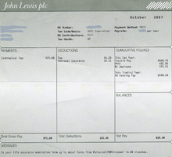
An example of a pay slip from the John Lewis Partnership, showing gross salary, tax and National Insurance paid and yearly bonus entitlement, among other things. A pay stub, pay stub, pay slip, pay advice, or sometimes paycheck stub, is a document an employee receives either as a notice that the direct deposit transaction has gone through, or as part of their paycheck. It will typically detail the gross income and all taxes and any other deductions such as retirement plan contributions, insurances, garnishments, or charitable contributions taken out of the gross amount to arrive at the final net amount of the pay, also including the year to date totals in some circumstances.
Payroll Card:
For employees that, for one reason or another, do not have access to a bank account (bad check history, not in close proximity to bank, etc), there is a solution, offered by most major Payroll Service Providers. Instead of an employee receiving a check, and paying up to 5-10% to cash the check, the employee can have the direct deposit loaded onto a debit card. In this, a company can save money on printing checks, not buy the expensive check stock, and not having to worry about check fraud, due to a check being lost or stolen. A payroll card is a plastic card allowing an employee to access their pay by using a debit card. A payroll card can be more convenient than using a check casher, because it can be used at participating automatic teller machines to withdraw cash, or in retail environments to make purchases. Some payroll cards are cheaper than payday loans available from retail check cashing stores, but others are not. Most payroll cards will charge a fee if used at an ATM more than once per pay period.

The payroll card account may be held as a single account in the employer's name. In that case, the account holds the payroll funds for all employees using the payroll card system. Some payroll card programs establish a separate account for each employee, but others do not.
Many payroll cards are individually owned dda (demand deposit accounts) that are owned by the employee. These cards are more flexible, allowing the employee to use the card for paying bills, and the accounts are portable. Most payroll card accounts are FDIC-insured, but some are not.
Payroll Frequencies:
Companies typically generate their payrolls on regular intervals, for the benefit of regular income to their employees. The regularity of the intervals, though, varies from company to company, and sometimes between job grades within a given company. Common payroll frequencies include: daily, weekly, bi-weekly (once every two weeks), semi-monthly (twice per month), and to somewhat of a lesser extent, monthly. Less common payroll frequencies include: 4-weekly (13 times per year), bi-monthly (once every two months), quarterly (once every 13 weeks), semi-annually (twice per year), and annually.
Payroll Professionals:
In Canada, Payroll Professionals are certified by the Canadian Payroll Association. They are qualified as either 'Payroll Compliance Practitioners (PCP)' or as 'Certified Payroll Managers (CPM)'.
In the United States, Payroll Professionals are certified by the American Payroll Association. They are designated as Fundamental Payroll Certification (FPC) or Certified Payroll Professional (CPP) after passing the appropriate certification exam. Upon completion of the required course material and with continuing education and membership fees the person is then entitled to the post-nominal letters associated with their current level of accomplishment.
In the United Kingdom, payroll professionals are represented by the Institute of Payroll Professionals. In Ireland both the Irish Payroll Association (IPASS) and Complete Office Package Systems Ltd provides education and training for payroll professionals. IPASS are the representative body for payroll professionals in Ireland. The Irish Government education body HETAC accredits the IPASS Payroll and VAT qualifications.
Warrants:
Payroll warrants look like checks and clear through the banking system like checks, but are not drawn against cleared funds in a deposit account. Instead they are drawn against "available funds" that are not in a bank account, so the issuer can collect interest on the float. In the US, warrants are issued by government entities such as the military and state and county governments. Warrants are issued for payroll to individuals and for accounts payable to vendors. Technically a warrant is not payable on demand and may not be negotiable.^{[2]} Deposited warrants are routed to a collecting bank which processes them as collection items like maturing treasury bills and presents the warrants to the government entity's Treasury Department for payment each business day.
In the UK, warrants are issued as payment by the NS&I when a Premium Bond is chosen.
Payroll Outsourcing:
Businesses may decide to outsource their payroll functions to an outsourcing service like a payroll bureau or a fully managed payroll service. These can normally reduce the costs involved in having payroll trained employees in-house as well as the costs of systems and software needed to process payroll. Within the United States, business payrolls are complicated in that taxes must be filed consistently and accurately to applicable regulatory agencies. Restaurant payrolls which typically include tip calculations, deductions, garnishments and other variables can be extremely difficult to manage especially for new or small business owners.
In the UK, payroll bureaus will deal with all HM Revenue & Customs enquiries and deal with employee's queries. Payroll bureaus also produce reports for the businesses' account department and pay slips for the employees and can also make the payments to the employees if required.
Another reason many businesses outsource is because of the ever increasing complexity of payroll legislation. Annual changes in tax codes, PAYE and National Insurance bands as well as more and more statutory payments and deductions having to go through the payroll often mean there is a lot to keep abreast of in order maintaining compliance with the current legislation.

Pay rolling:
Pay rolling is the business practice of referring a contingent worker to a staffing vendor or pay rolling provider so that they are the employer of record responsible for employer taxes, payroll, and all legal matters pertaining to employing workers. Different from sourcing (or recruiting) where the staffing vendor uses internal recruiters to locate contractors on behalf of the requesting company or client, pay rolled workers are identified by the client.
Often pay rolled workers are known to the client from previous engagements or as former employees. Because the costs of recruiting workers in to contract positions are eliminated the pay roles are often processed at reduced mark up rates.
In the last several years, some dedicated pay rolling companies have emerged in the staffing industry to provide pay rolling services at greatly reduced pricing around the world.
See also:
Human Resource is the most vital resource for any organization. It is responsible for each and every decision taken, each and every work done and each and every result. Employees should be managed properly and motivated by providing best remuneration and compensation as per the industry standards. The lucrative compensation will also serve the need for attracting and retaining the best employees.
Compensation is the remuneration received by an employee in return for his/her contribution to the organization. Compensation is an integral part of human resource management which helps in motivating the employees and improving organizational effectiveness.
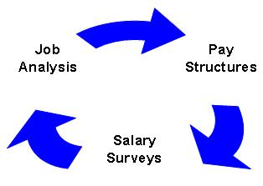
Components of Compensation System:
Compensation systems are designed keeping in minds the strategic goals and business objectives. Compensation system is designed on the basis of certain factors after analyzing the job work and responsibilities. Components of a compensation system are as follows:

Types of Compensation:
Compensation provided to employees can direct in the form of monetary benefits and/or indirect in the form of non-monetary benefits known as perks, time off, etc. Compensation does not include only salary but it is the sum total of all rewards and allowances provided to the employees in return for their services. If the compensation offered is effectively managed, it contributes to high organizational productivity.
Direct Compensation
Indirect Compensation
Need of Compensation Management
- A good compensation package is important to motivate the employees to increase the organizational productivity.
- Unless compensation is provided no one will come and work for the organization. Thus, compensation helps in running an organization effectively and accomplishing its goals.
- Salary is just a part of the compensation system, the employees have other psychological and self-actualization needs to fulfill. Thus, compensation serves the purpose.
- The most competitive compensation will help the organization to attract and sustain the best talent. The compensation package should be as per industry standards.


Strategic Compensation:
Strategic compensation is determining and providing the compensation packages to the employees that are aligned with the business goals and objectives. In today’s competitive scenario organizations have to take special measures regarding compensation of the employees so that the organizations retain the valuable employees. The compensation systems have changed from traditional ones to strategic compensation systems.
Payroll Management Processes
Calculation of gross salaries and deductible amounts is a tedious task which involves risk. Some of the organizations use the traditional manual method of payroll processing and some go for the advanced payroll processing software. An organization opts for any of the following payroll processing methods available:
Manual System
Manual payroll system is the traditional payroll system which involves pen and ink, adding machine, spreadsheet, etc instead of computers, software and other computerized aids. The process was very popular when there were no computerized means for payroll processing.
Now-a-days it is only few small scale organizations in the remote areas that use the manual payroll. Sometimes the construction industry and manufacturing industry also use the manual payroll systems for the contractual labour, as theses contracts are on daily/weekly basis.
There is full control in the hands of owner. But the process is tedious, time consuming and risky as it is more prone to errors.

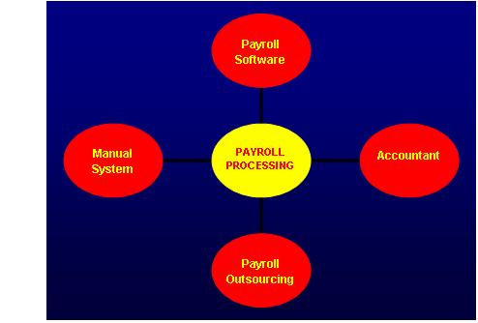
Figure: Various Payroll Processes

Accountant:
Accountant is a professional having a degree/diploma course in finance/accountancy. He/she is responsible for all the activities related to payroll accounting. He/she has the sound knowledge of accounting principles and globally accepted standards. The process adds costs to the organization. It involves paying someone who is responsible for calculating the salaries of others. The financial control regarding salary goes in the hand of accountant.
Payroll Software:
In today’s computerized environment, payroll system has also developed itself into automated software that performs every action needed by the payroll process. It helps in calculating the payable amounts and deductions very easily. It also helps in generating the pay slips in lesser time. Automated calculations result in no errors. Data is validated automatically by the software. It needs professionals to make use of the software for its efficient working.
Payroll Outsourcing
Payroll outsourcing involves a third party (an outsourcing company) in the calculations of salaries and deductions. The outsourcing organization is responsible for all the activities of the payroll accounting. It saves time and cost for the organization. If there is more number of employees (say more than 900-1000) in the organization, payroll outsourcing would be very much beneficial.
The data is provided to the consultants/outsourcing firms. The various payroll functions undertaken by the outsourcing organizations are as follows:
- Analysis of Payroll records, payroll taxes
- Medical claim processing

CHAPTER-IV
DATA ANALYSIS
&
INTERPRETATION

DATA ANALYSIS AND INTERPRETATION

- How long have you been associated with this organization?

Aspects | No. of respondents | Percentage (%)
Below 1 year | 10 | 25
1 to 2 years | 24 | 40
2 to 4 years | 10 | 17
4 to 6 years | 06 | 10
More than 6 years | 05 | 08
Total | 60 | 100

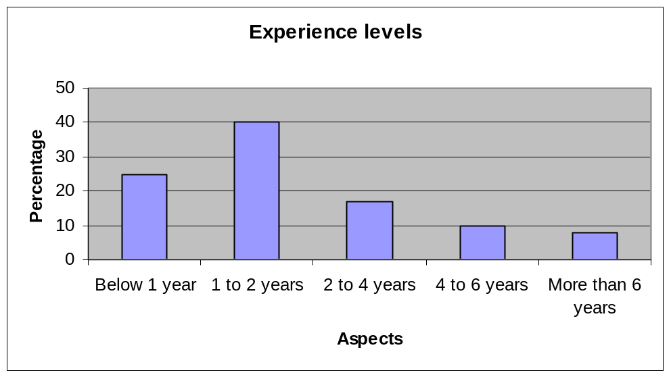

INTERPRETATION:

In the above analysis it shows that out of all respondents, 25% of respondents are working with the organization below one year, 40% of respondents are working with the organization between 1 to 2 years, 17% of respondents are working with the organization between 2 to 4 years, 10% of respondents are working with the organization between 4 to 6 years and 8% of respondents are working with the organization above the 6 years..

- What is the level of the employee grade in organizational hierarchy?

Aspects | No. of respondents | Percentage (%)
Level 1 | 40 | 67
Level 2 | 20 | 33
Level 3 | 00 | 00
Total | 60 | 100

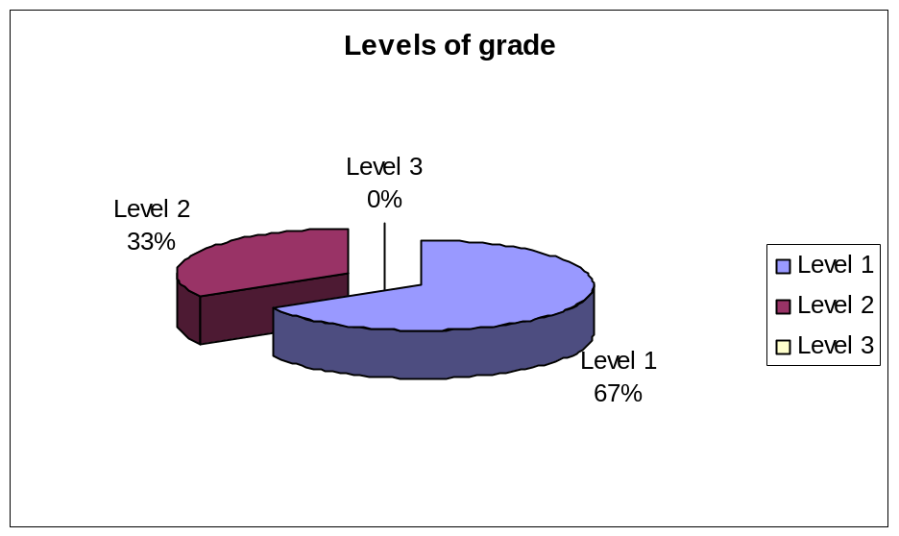

INTERPRETATION:

In the above analysis it shows that out of all respondents, 67% of more respondents come under level 1 and 33% of respondents comes under level 2 of the organization.

- What is the salary range?

Aspects | No. of respondents | Percentage (%)
Below Rs5000/- | 26 | 43
Rs5000/- to Rs10000/- | 18 | 30
Rs10000/- to Rs15000/- | 12 | 20
Rs15000/- to Rs25000/- | 03 | 05
More than Rs25000/- | 01 | 02
Total | 60 | 100

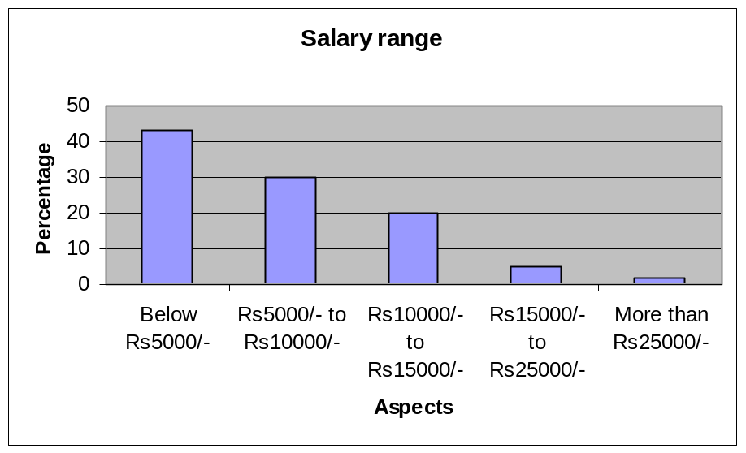

INTERPRETATION:

In the above analysis it shows that out of all respondents, 43% of respondents are working below the salary of Rs5000/-, 30% of respondents are working between the salary of Rs5000/- to Rs10000/-, 20% of respondents are working between the salary of Rs10000/- to Rs15000/-, 5% of respondents are working between the salary of Rs15000/- to Rs25000/- and 2% of respondents are working with the salary of above Rs25000/- .

- Considering the competitors pay package while determining the package of employees?

Aspects | No. of respondents | Percentage (%)
Yes | 26 | 43
No | 34 | 57
Total | 60 | 100

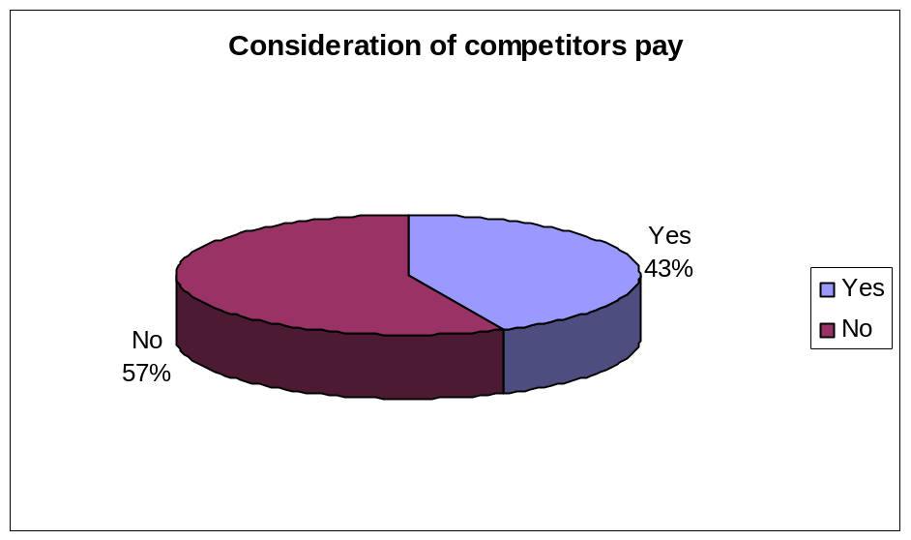

INTERPRETATION:

In the above analysis it shows that out of all respondents, 43% of respondents said yes, that they are considering competitors pay packages in determining their pay package and rest of 57% of more respondents said no to that.

- What are the factors used to determine the pay?

Aspects | No. of respondents | Percentage (%)
Competitors benchmarking | 30 | 50
Salary survey | 24 | 40
Any other | 06 | 10
Total | 60 | 100

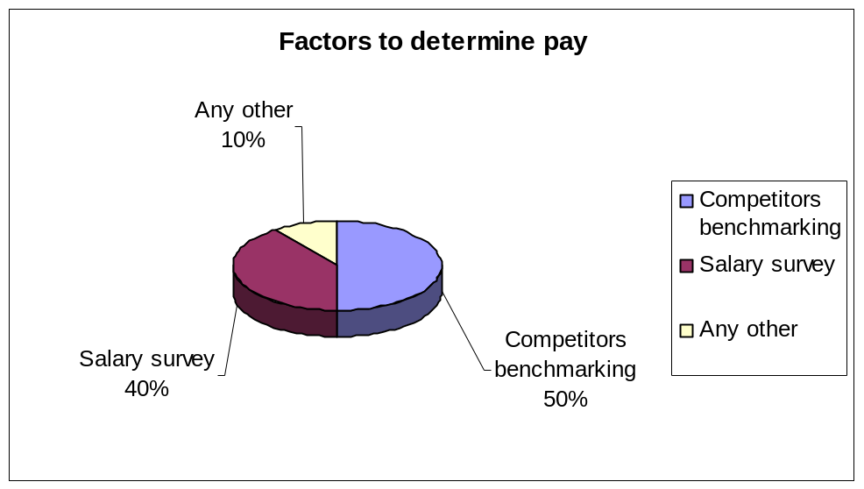

INTERPRETATION:

From the above analysis it shows that the out of all respondents, 50% of more respondents said they are using competitors benchmarking, 40% of respondents said they are using salary survey and 10% of respondents said don’t know the factors determining their pay.

- How often is the salary revised?

Aspects | No. of respondents | Percentage (%)
Every 3 months | 02 | 03
Every 6 months | 18 | 30
Every year | 40 | 67
Total | 60 | 100

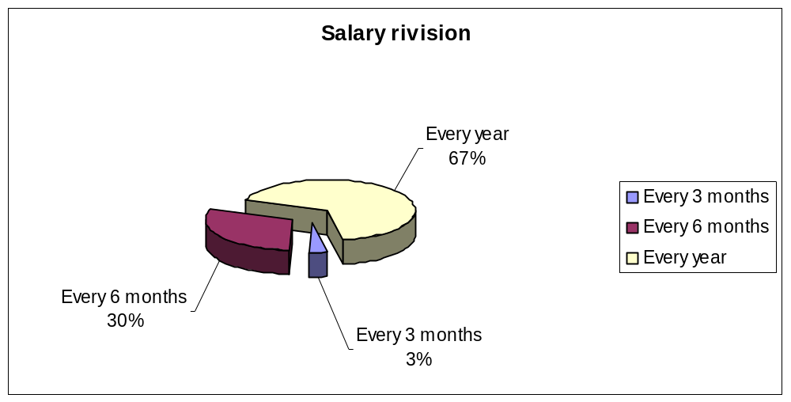

INTERPRETATION:

From the above analysis it shows that the out of all respondents, 67% of more respondents said that their salary is getting revised every year, 30% of respondents said that their salary is getting revised for every 6 months and rest of 3% of respondents said that their salary is getting revised for every 3 months.

- What are the satisfaction levels of pay?

Aspects | No. of respondents | Percentage (%)
Highly satisfied | 04 | 07
Satisfied | 08 | 13
Neither satisfied nor dissatisfied | 34 | 57
Dissatisfied | 12 | 20
Highly Dissatisfied | 02 | 03
Total | 60 | 100

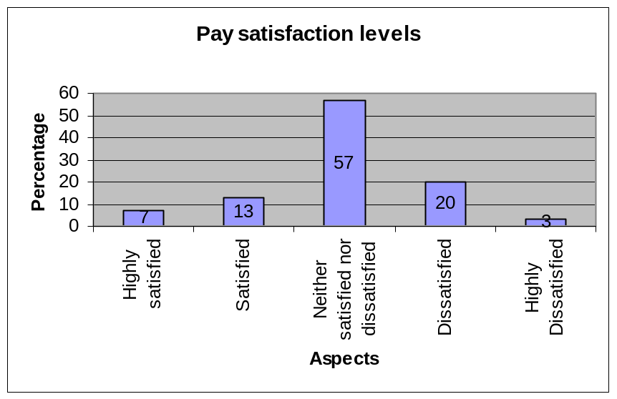

INTERPRETATION:

From the above analysis it shows that the out of all respondents, 57% of more respondents neither satisfied nor dissatisfied, 20%of respondents dissatisfied, 13% of respondents satisfied, 7% of respondents highly satisfied and 3% of respondents highly dissatisfied with the providing pay packages in the organization.

- Is the organizational pay structure motivating employee towards work?

Aspects | No. of respondents | Percentage (%)
Yes | 26 | 43
No | 34 | 57
Total | 60 | 100

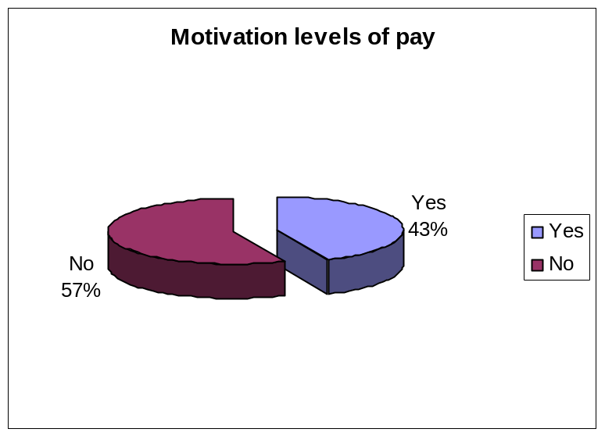

INTERPRETATION:

In the above analysis it shows that out of all respondents, 43% of respondents said yes and rest of 57% of more respondents said no to that they are not getting motivated by their pay package.

- Is the organization providing merit pay?

Aspects | No. of respondents | Percentage (%)
Yes | 20 | 43
No | 40 | 57
Total | 60 | 100

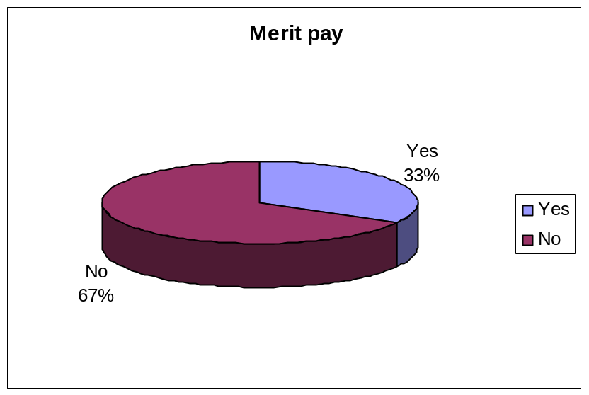

INTERPRETATION:

In the above analysis it shows that out of all respondents, 33% of respondents said yes, that they are getting paid for merit and rest of 67% of more respondents said no to that.

- Is the pay structure retaining employee to this organization?

Aspects | No. of respondents | Percentage (%)
Highly satisfied | 04 | 07
Satisfied | 10 | 17
Neither satisfied nor dissatisfied | 32 | 53
Dissatisfied | 12 | 20
Highly Dissatisfied | 02 | 03
Total | 60 | 100

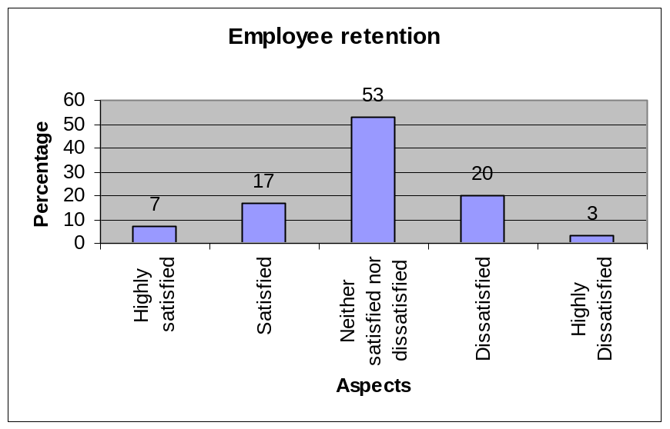

INTERPRETATION:

From the above analysis it shows that the out of all respondents, 53% of more respondents neither satisfied nor dissatisfied, 20%of respondents dissatisfied, 17% of respondents satisfied, 7% of respondents highly satisfied and 3% of respondents highly dissatisfied with their retention because of pay packages in the organization.

CHAPTER-V
FINDINGS
SUGGESTIONS
CONCLUSION

FINDINGS
  - Most of the employees working in the organization have the service between 1 to2 years.
  - Most of the employee pay grades fall in the level 1.
  - Most of the employees are working under the salary range of below Rs5000/-.
  - Most of the employees disagree that organization is not considering competitor pay structure in determining pay.
  - Most of the employees say bench marking is the determining factor of pay.
  - Most of the employees say that the salary is getting revised every year.
  - Most of the employees neither satisfied nor dissatisfied with their salaries.
  - Most of the employees say that pay is not at all motivating towards work.
  - Most of the employees say that they are not getting provided merit pay.
  - Most of the employees neither they satisfied nor dissatisfied in retaining to the organization about the pay.

SUGGESTIONS
  - Employees are expecting merit pay, so they want their pay based upon their performance.
  - Company has to focus on the experienced employees not to go away from the organization.
  - The satisfaction levels of employees regarding salary is less, so better to provide fair remuneration.
  - Along with salary, providing other facilities like food coupons may retain lower level employees.
  - It is better to make the employee know exactly on what basis salary is getting determined, it may lead to satisfy, motivate, retain to organization.
CONCLUSION
  - From the Questionnaire which we have collected from the employees, we can conclude that the age group in organization was from below 1 year to above 6 years.
  - Most of the employee pay grades fall in level 1 and level 2 of the hierarchy.
  - The range of the salary starts from below Rs5000/- to above Rs25000/-.
  - Concluded that the various factors used to determine the pay.
  - The multiple voices of satisfaction levels were seen.
  - It was concluded that employee retention was in balanced stage in the organization.

ANNEXURE-I
BIBLIOGRAPHY
S.NO. | AUTHOR | TITLE | EDITION | PUBLISHER | YEAR
1. | P. SUBBA RAO | HR Management | 5”Edition | TATA Mc Graw | 2015
2. | STEPHEN ROBBINS | PERSONNEL HUMAN RESOURCE MGMT | 4”Edition |  | 2013
3. | WAYNE F CASCIO | INFORMATION SYSTEMS APPROACH | 4”Edition | TATA Mc Graw | 2015

WEBSITES:
  - www.big bazaar.com
  - www.panthalone.com
  - www.futuregroup.com
  - www.hr.ucdavis
  - http:///www.hr.uwa.edu

QUESTIONNAIRE ON PAYROLL MANAGEMENT

Name: _______________________________ Age: ___________________
Designation: ________________________ Qualification: _____________

- How long have you been associated with this organization? ( )
a) Below 1 year b) 1 to 2 years c) 2 to 4 years
d) 4 to 6 years e) More than 6 years
- What is the level of the employee grade in organizational hierarchy? ( )
a) Level 1 b) Level 2 c) Level 3
- What is the salary range? ( )
a) Below Rs5,000/- b) Rs5,000/- to Rs10,000 c) Rs10,000/- to Rs15,000/-
d) Rs15,000/- to Rs25,000/- e) Above Rs25,000/-
- Considering the competitors pay package while determining the package of employees? ( )
a)Yes b)No
- What are the factors used to determine the pay?
a) Competitors benchmarking b) Salary survey c) Any other (Please specify)
- How often is the salary revised? ( )
a) Every 3 months b) Every 6 months c) Every year
- What are the satisfaction levels of pay? ( )
a) Highly satisfied b) Satisfied c) Neither satisfied nor dissatisfied
d) Dissatisfied e) Highly dissatisfied
- Is your organizational pay structure motivating you towards work? ( )
a)Yes b)No
- Is the organization providing merit pay? ( )
a)Yes b)No
- Is the pay structure retaining employee to this organization? ( )
a) Highly satisfied b) Satisfied c) Neither satisfied nor dissatisfied
d) Dissatisfied e) Highly dissatisfied

